**Migratory situation in April – Fewer migrants reach Europe**

2019-05-14

In April, the number of detections of illegal border crossings on Europe’s main migratory routes fell by 19% from the previous month to 4 900, mainly due to a drop in the Eastern Mediterranean. The total for the first four months of 2019 was 27% lower than a year ago at around 24 200.  
  
**Eastern Mediterranean**  
The Eastern Mediterranean route accounted for more than half of irregular migrants detected at EU borders in April. It remained the busiest migratory route into Europe despite lower activity than in March, mainly because of poor weather conditions. The number of migrants taking this route last month fell by one-fourth to 2 940.  
In the first four months of this year, the total number of detections in this region fell 18% from a year ago to close to 12 750.    
One out of four detected migrants in this route were nationals of Afghanistan, usually arriving by sea. One out of every five was of Turkish nationality, mainly crossing the land border.  
  
**Western Mediterranean**  
The number of irregular migrants taking the Western Mediterranean in April doubled from the previous month to around 900.  
The total for the January-April period rose to more than 6 300, or nearly one-third above the figure from the same period of last year.    
Nationals of Morocco, Guinea,  Mali and Ivory Coast accounted for the largest number of detected migrants on this route in the first four months of 2019.

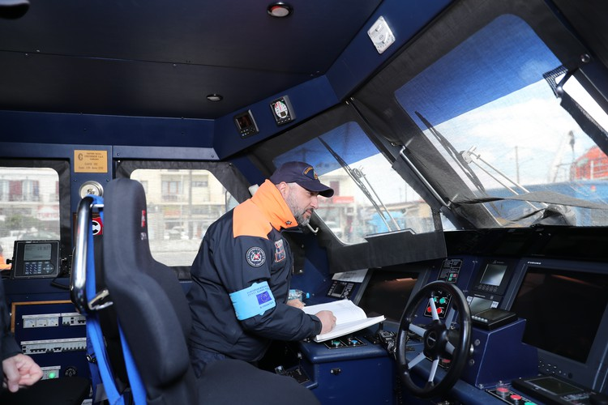

**Central Mediterranean**  
The number of migrants passing through the Central Mediterranean in April halved from March to slightly more than 200.  
The total for the first four months of the year was 91% lower from a year ago at around 880.  
Tunisians and Algerians were the most represented nationalities reaching Italy in the January-April period.  
  
**Western Balkans**  
There were more than 600 detections of illegal border crossings recorded on this route in April. The total for the first four months reached nearly 3 400 or 96% more than a year ago.  
Nationals of Afghanistan and Iran accounted for the largest share of migrants detected on this route.  
  
Note: The data presented in this statement refer to the number of detections of irregular border-crossing at the external borders of the European Union. The same person may attempt to cross the border several times in different locations at the external border.